Client management application

Sandra Uddman

1. Created angular project in cmd;

*\*Ng new clientmanagmentapp*

1. Created client form component

*\*ng g c client-form*

1. And client service:

*\*ng g s client*

1. Installed bootstrap

*\*Npm install bootstrap*

1. Created navbar in app.component.html and provided router paths in app.router.module.ts using bootstrap

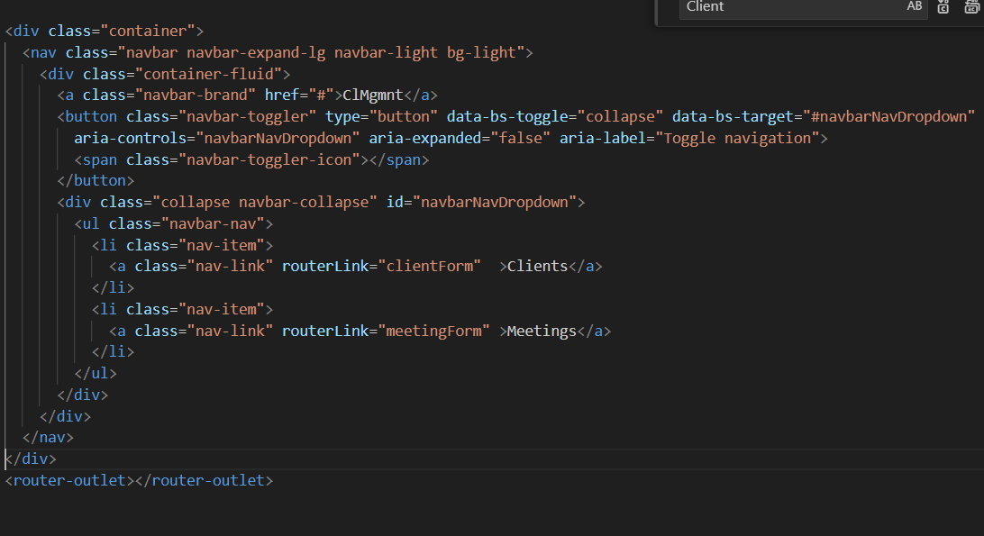

1. Started working on client-form.component .html creating a Reactive form.

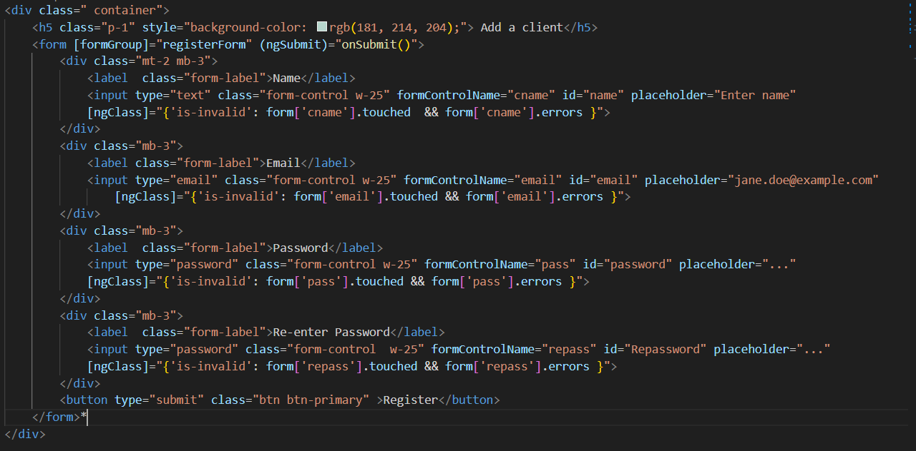

1. Coded client.service.ts

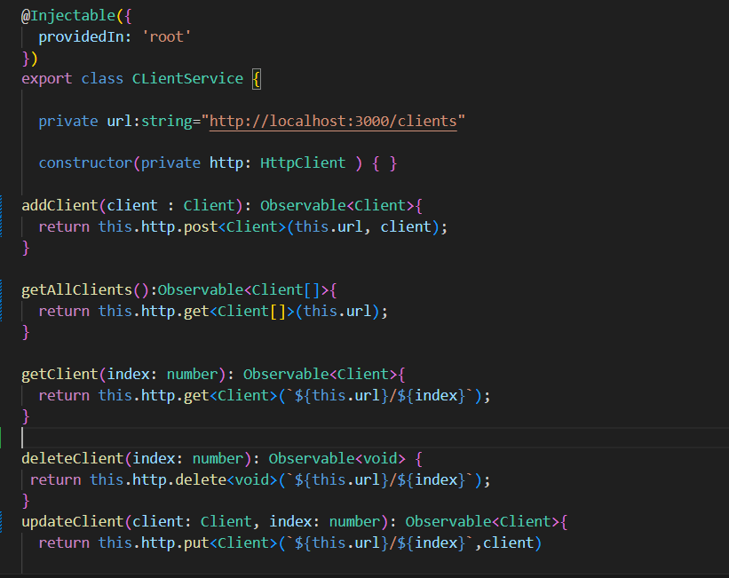

1. Coded client-form.component.ts

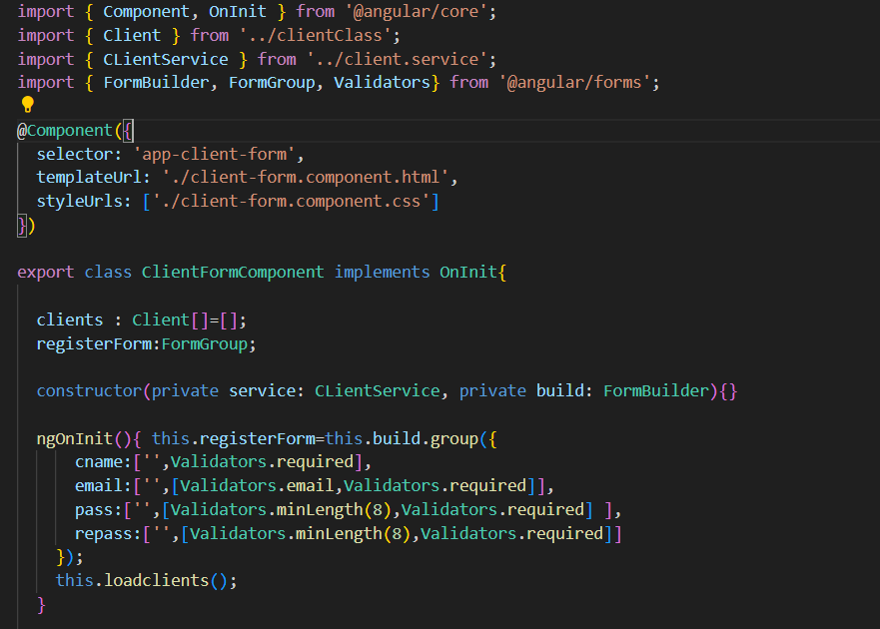

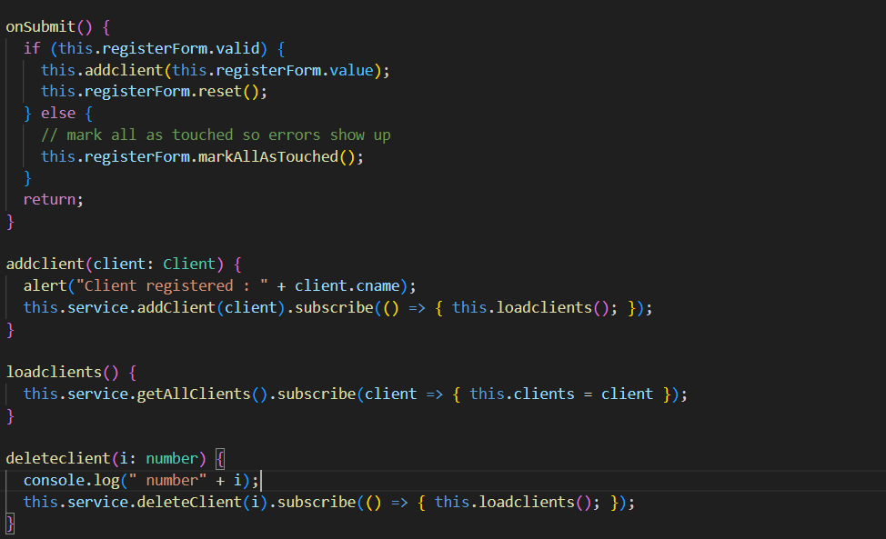

1. Created list of clients as a table in client-form.component.html

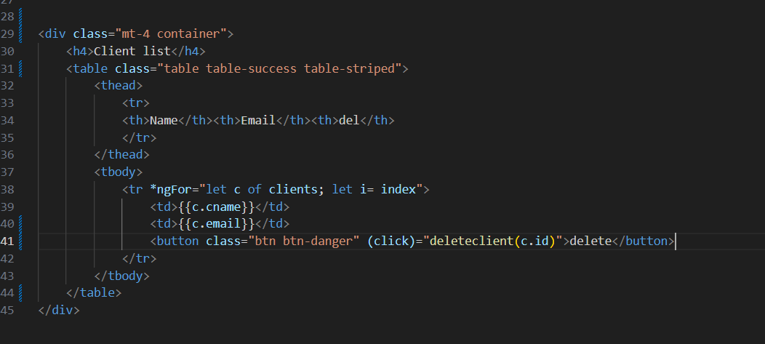

1. Created a new component for meetings.

*\*ng g c meeting-form*

1. Created service for meeting:  
    *\*ng g s meeting*
2. Code for getting input of a meeting creation as a reactive form in meeting-form.component.html

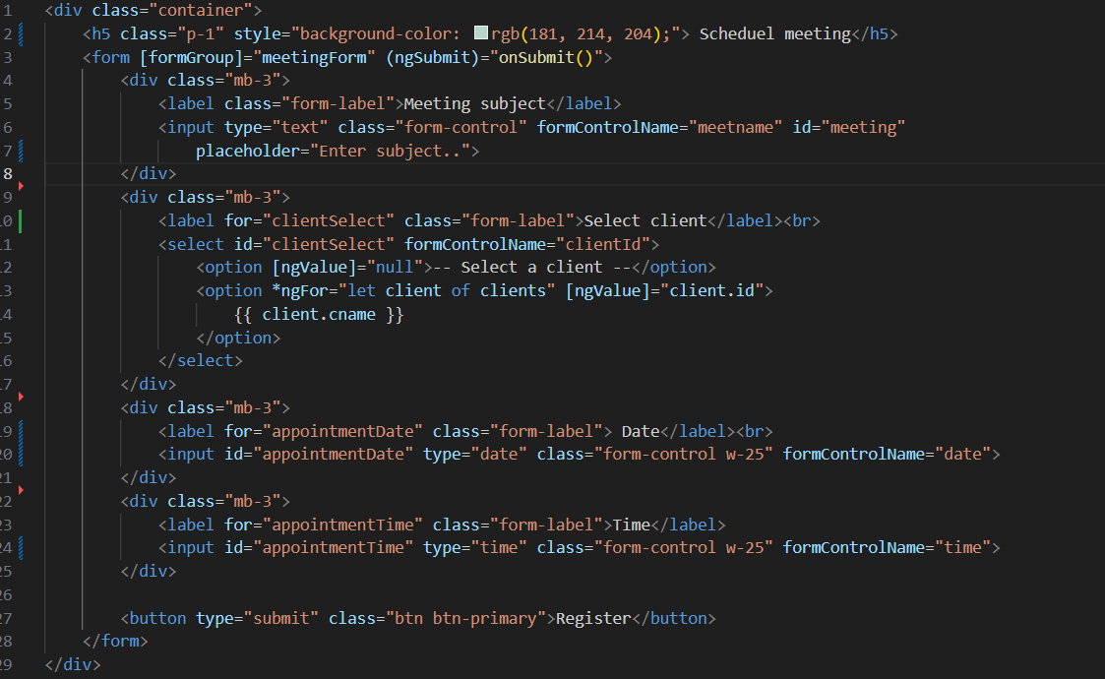

1. Code for meeting-form.component.ts file

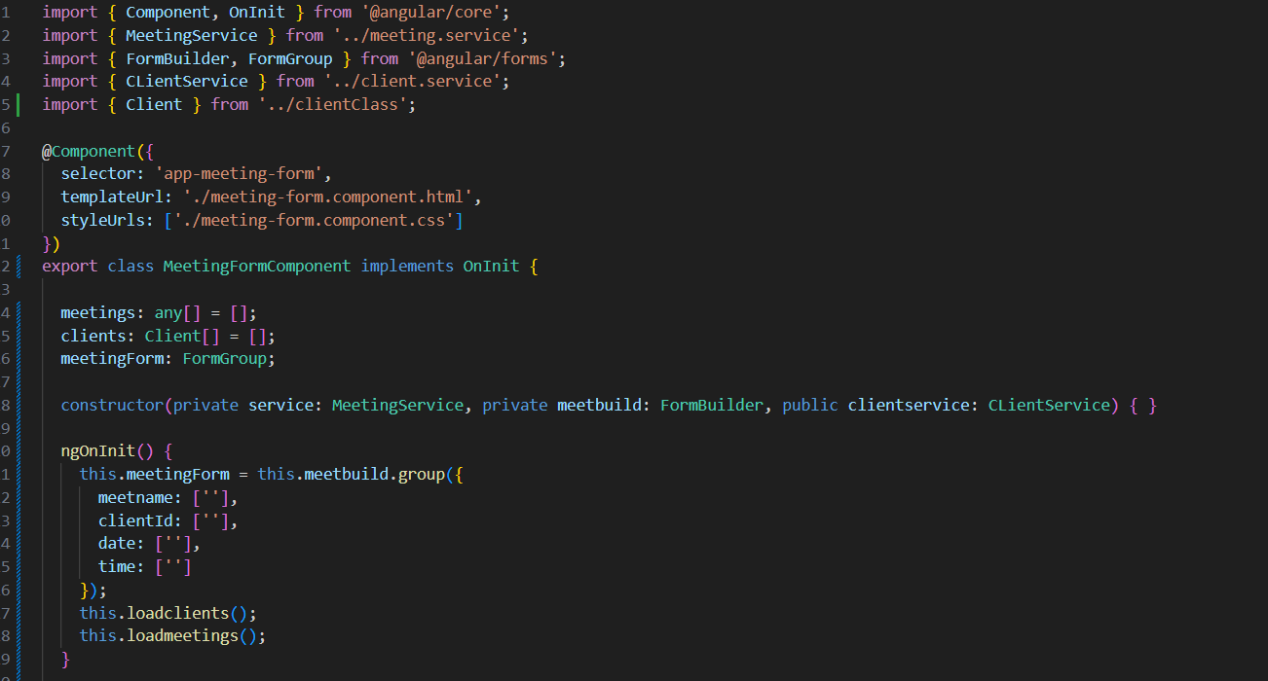

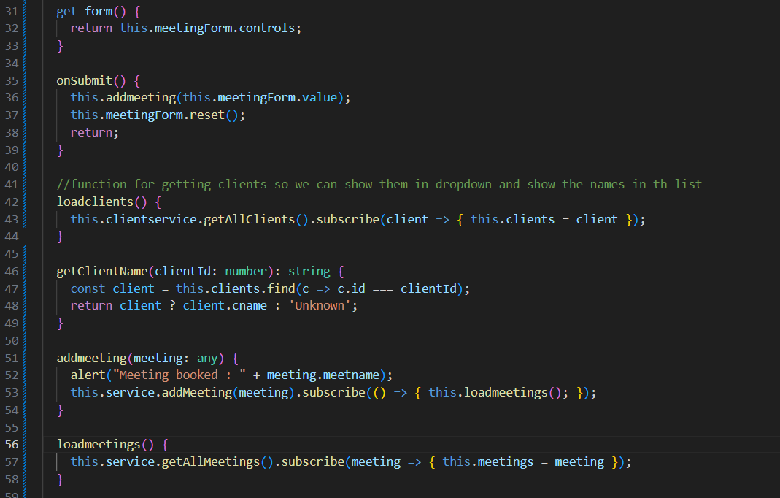

1. Code for meeting service

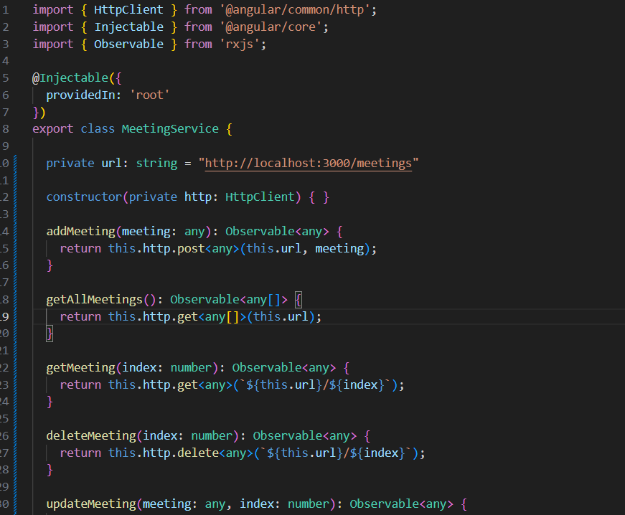

1. Extra fixes.

added validation on client form, implemented class type client, fixed a getmethod for client name in meeting list. Improved tables and UI a bit.